Date: 29/04/2026
Department of Artificial Intelligence and Machine Learning
Minutes of meeting of 5th Board of Studies (BoS) of Department of Artificial Intelligence and Machine Learning conducted online on 29/04/2026 (Wednesday) at 10.30 am
Following Members were present for BOS Meeting
Sr. No. | Name and Affiliation of BOS Members | Designation in BOS Committee
 | Mr. Ajay Sirsat,  Assistant Professor & HOD, Department of Artificial Intelligence and Machine Learning,  St. John College of Engineering and Management, Palghar | BOS Chairman
 | Dr. Tatwadarshi Nagarhalli  Associate Professor, Department of Artificial Intelligence and data Science,  Vidyavardhini’s College of Engineering and Technology, Mumbai | VC Nominee, University of Mumbai
 | Dr. L.M.R.J. Lobo  Professor  Department of,  Walchand Institute of Technology, Kolhapur, Maharashtra,india | Subject Expert 01  Outside the parent University
 | Dr. Shreenath Acharya  Professor, Department of  St. Joseph Engineering College, Vamanjoor, Mangalore- 575028, Karnataka, India | Subject Expert 02  Outside the parent University
 | Mr. Jetso Analin  CEO,  Web5 Nexus,  Mumbai | Expert from Industry/corporate sector/allied areas
 | Dr. Chandrkant Bothe  Founder,  YOLOvX,  Hamburg, Germany | Expert from Industry/corporate sector/allied areas
 | Mr. Jayesh Patil  National Stock Exchange, Bandra, Mumbai.  Mr. Devang S. Vartak  Associate Software Engineer,LeanQubit, Mumbai | Alumni Member
 | Dr. Pratik Kanani  Associate Professor, Department of Artificial Intelligence and Data Science  SVKM’s Dwarkadas J. Sanghvi College of Engineering, Mumbai | Experts from outside the Autonomous College
 | Mr. Sandeep Dwivedi  Member, Assistant Professor, Dept.of AIML., SJCEM | Member
 | Mrs. Juily Tarade,  Member, Assistant Professor, Dept.of AIML., SJCEM | Member
 | Mrs. Rosy Pradhan,  Member, Assistant Professor, Dept.of AIML., SJCEM | Member
 | Mrs. Trusha Sankhe,  Member, Assistant Professor, Dept.of AIML., SJCEM | Member
 | Ms. Sweta Kawale  Member,Teaching Assistant,Dept of AIML,  SJCEM | Member

Meeting was conducted on November 4, 2025 for the discussion of syllabus scheme SJCEM R-24B to be implemented by Department of Artificial Intelligence and Machine Learning for the academic year 2025-26 Even semester.

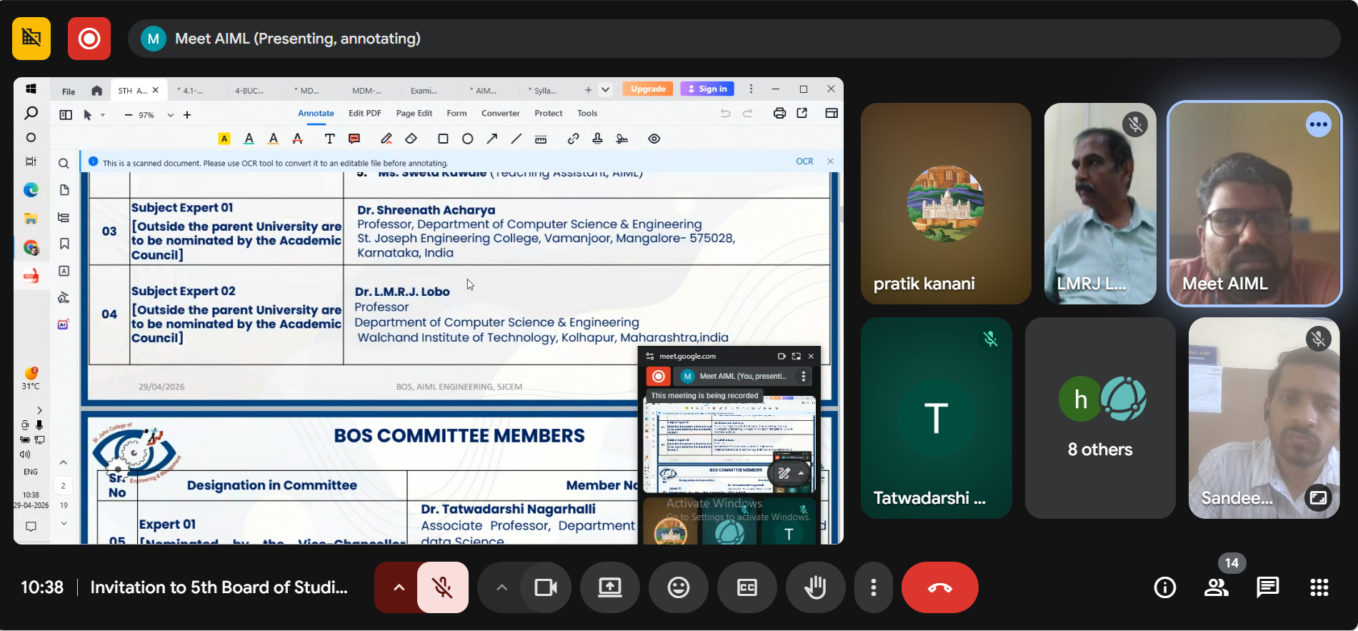Meeting started with welcome and introduction of BOS members by Mr. Ajay Sirsat
Item 1: To consider and approve minutes of meeting of the 4th Board of Studies (BOS) held on 4th November 2025.
Resolution: The BOS approved the minutes of meeting of 4^{t} Board of Studies (BOS) held on 4th November 2026.
Item 2: To consider and approve the action taken report of minutes of 4th Board of Studies (BOS) held on 4th November 2026.
Resolution: The BOS approved the Action taken of the 4th Board of Studies (BOS) held on 4th November 2026.
Item 3: To discuss and recommend Curriculum design in the Department of Artificial Intelligence and Machine Learning, w.r.t NEP 2020 and Autonomy requirements for Semesters IV, VI and VIII.
Resolution: Curriculum design, development and Implementation w.r.t NEP 2020 and Autonomy requirements for Semesters IV, VI and VIII was discussed and recommended to Academic Council (Annexure-III).
Item 4: To approve the scheme SJCEM: R-25B of A.Y. 2026-27 (Odd Semester) to be forwarded to Academic Council.
Resolution: The BOS approved the scheme SJCEM: R-25B for A.Y. 2026-2027 for Fourth Semester, Sixth Semester and Eighth Semester of B. Tech in Department of Artificial Intelligence and Machine Learning Program.

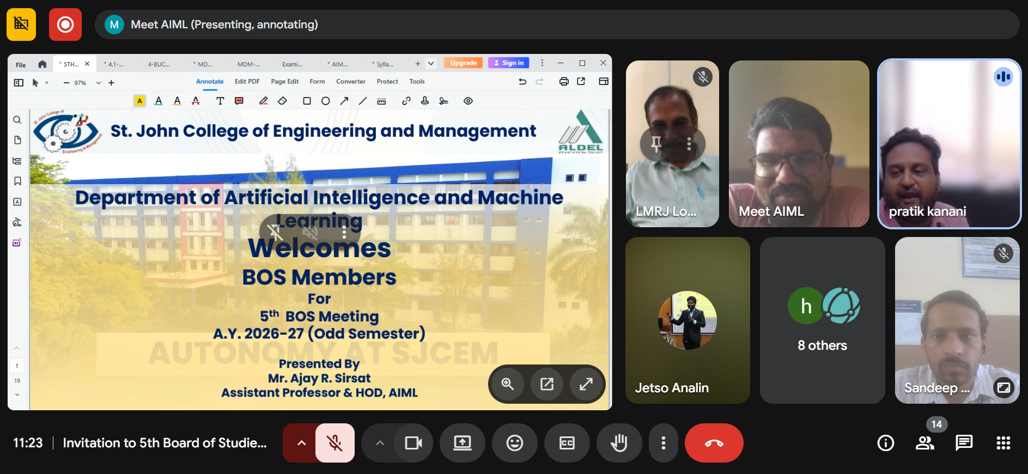
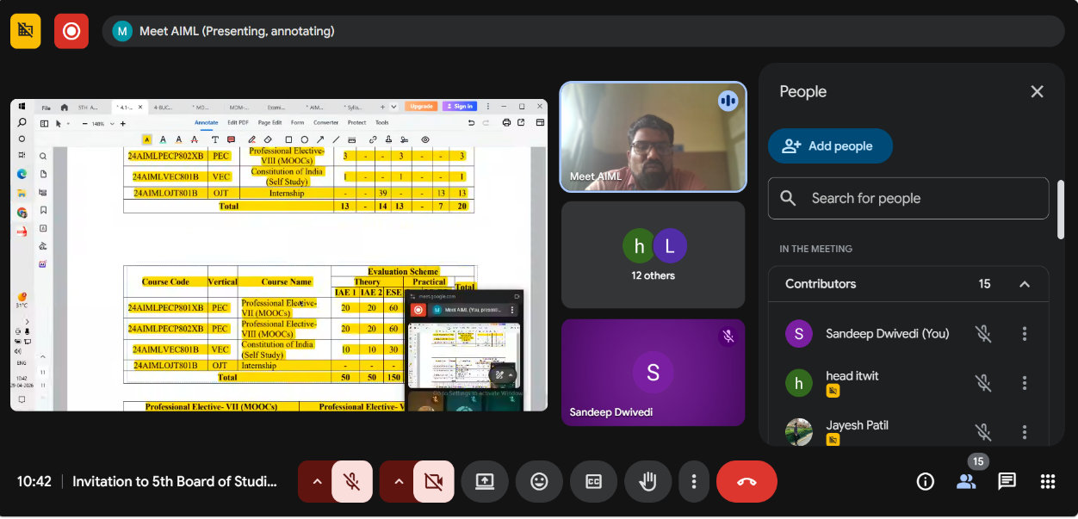
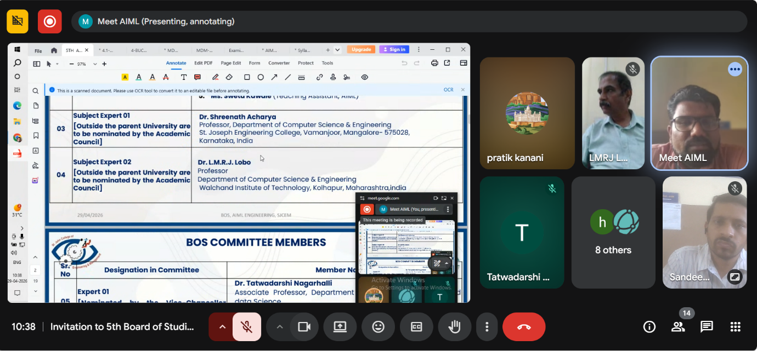
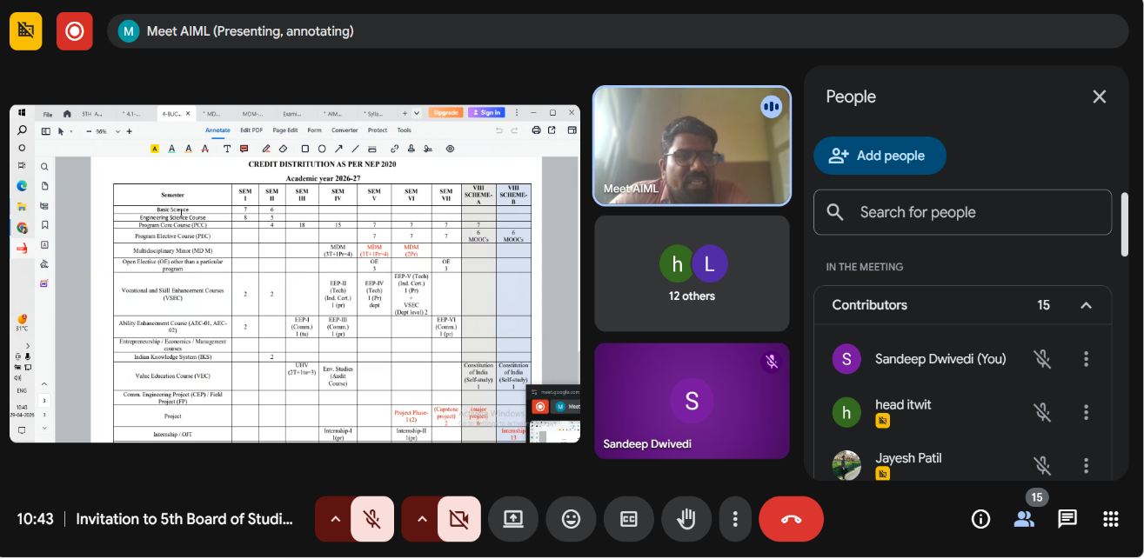
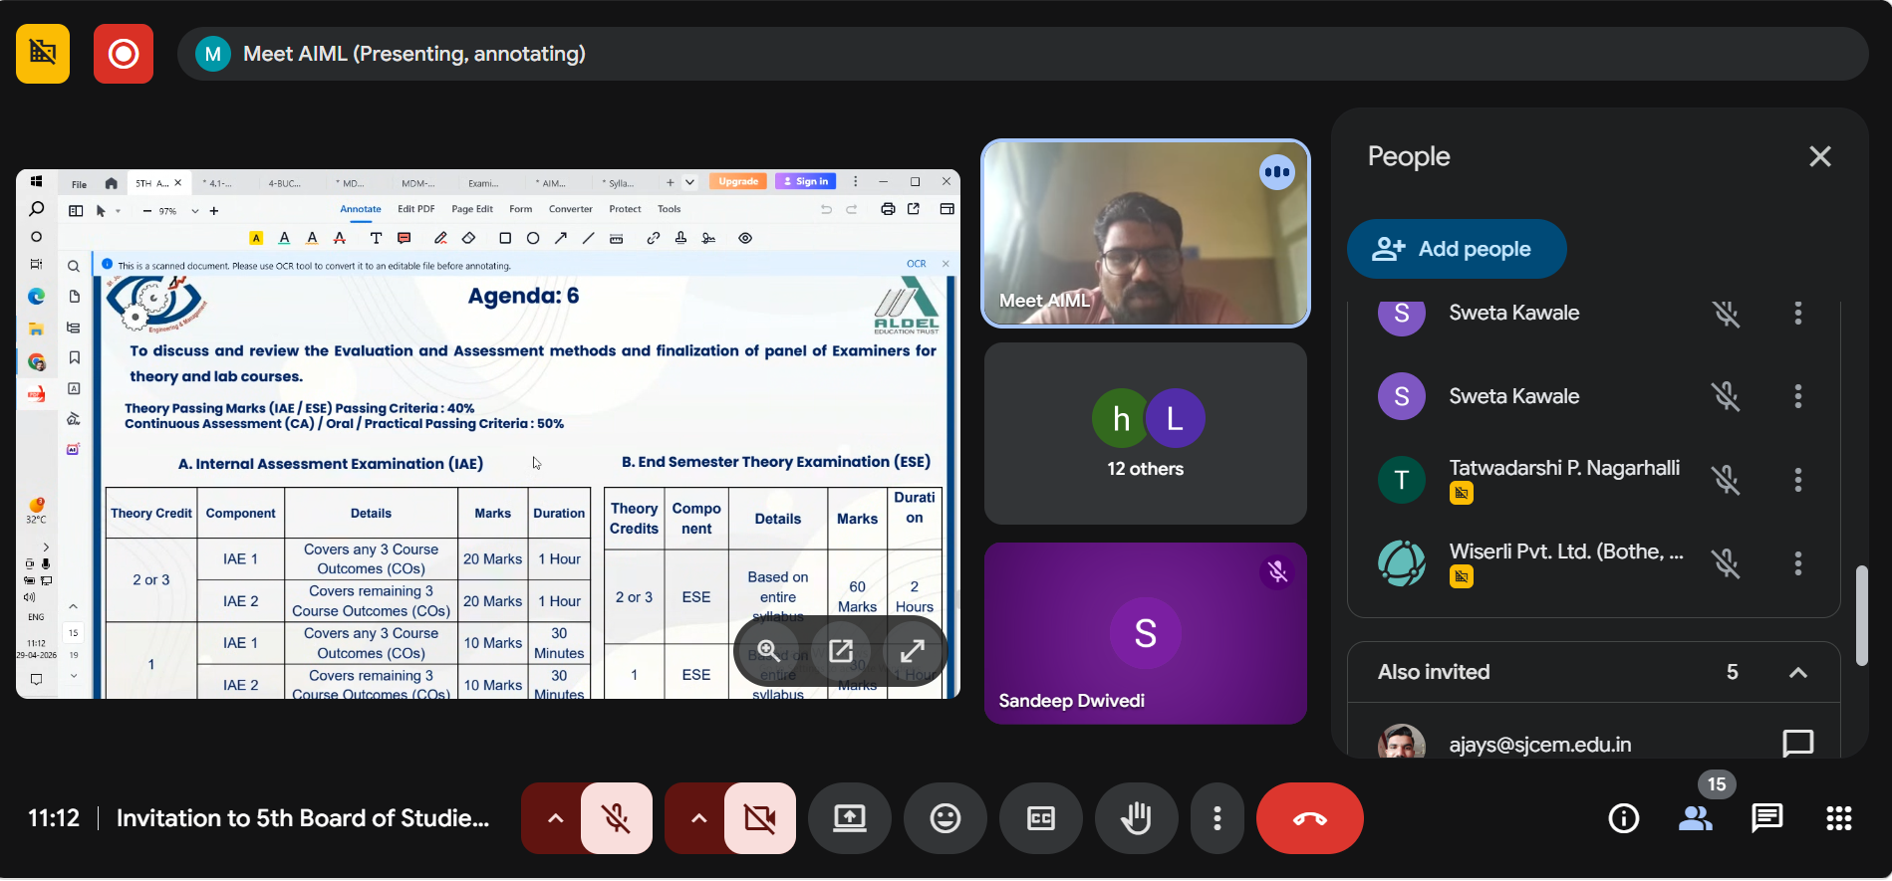
Item 5: To discuss and recommend the academic productivity in teaching- learning process, project quality and semester conduct to meet the requirement of outcome based education (OBE).
Resolution: Academic productivity in classroom and laboratory to meet the requirement of Outcome based Education is discussed and recommended.
Item 6: To discuss and recommend the evaluation and assessment methods and finalization of a panel of Examiners for theory and lab courses for the even semester of A.Y. 2025-26.
Resolution: Evaluation and assessment scheme is shown in the syllabus of respective subjects. Evaluation and Assessment methods was discussed and confirmed. Panel of Examiners for theory and lab courses was discussed and confirmed unanimously by all BOS members.
Evaluation and Assessment Scheme:
- Internal Assessment Examination (IAE):
Assessment consists of two class tests, each 20 marks. The IAE 1 will cover any three Course Outcomes (COs) and IAE 2 will cover the remaining three Course Outcomes (COs). Each test will have duration of one hour.
- End Semester Theory Examination (ESE):
End Semester exam of 60 Marks will be conducted based on entire syllabus.
- Continuous Assessment (CA) :
Continuous Assessment should consist of the following
Experiments / Tutorials (8 to 10): 10 marks (All COs / LOs should be covered)
Attendance (Theory & Practical): 05 marks
Teacher Assessment Examination (TAE): 10 Marks

List of Teacher Assessment Examination (TAE):
  - Assignment
  - Case Study
  - Debate
  - Solution for Social Problems
  - Field Visit
  - Group Project
  - Flipped Classroom
  - Topic Review
  - Quiz
  - Mind Mapping
  - Any other
Note: Number of activities to be conducted under TAE would be as per the subject need.
- Oral & Practical Exam
Based on the entire syllabus, oral (10 marks) & practical/implementation (15 marks) examination will be conducted.

Department of Artificial Intelligence and Machine Learning
Departmental Examiner Panel
Semester- III
Scheme: SJCEM: R-25
Course Code | Vertical | Course Name | Examiner 1 | Examiner 2 | Examiner 3
25AIMLPCC301 | PCC | Applied Mathematics for AI | Mrs. Reshma Chavan  9867030907  reshmac@sjcem.edu.in | Mrs. Dhanashree Pawgi  9624017727  dhanashreep@sjcem.edu.in | Mr. Mayur Gohil  VCET, Vasai  8355801862  mayurgohil@gmail.com
25AIMLPCC302 | PCC | Data Structures | Mr.Sandeep Diwedi  9579118693  sandeepd@sjcem.edu.in | Mrs. Trusha Sankhe  9637245024  trushas@sjcem.edu.in | Mrs. Prachiti Pimple  SFIT  7666017251  prachiti@sfit.ac.in
25AIMLPCC304 | PCC | Database Management System | Mrs. Trusha Sankhe  9637245024  trushas@sjcem.edu.in | Mrs. Rosy Pradhan  9766160629  rosyp@sjcem.edu.in | Mrs. Krunali Vartak  VCET  8149707902  krunali.vartak@vcet.edu.in
25AIMLPCC303 | PCC | Microprocessor and Computer Architecture | Mrs. Rosy Pradhan  9766160629  rosyp@sjcem.edu.in | Mr.Sandeep Diwedi  9579118693  sandeepd@sjcem.edu.in | Dr. Yogita Mane  TCET  9764257447  yogita.ydmane@gmail.com
25AIMLPCC306 | PCC | Programming Language I  (Python) | Mr.Sandeep Diwedi  9579118693  sandeepd@sjcem.edu.in | Mrs. Rosy Pradhan  9766160629  rosyp@sjcem.edu.in | Dr. Nilesh Patil  DJSCE  7350791320  nilesh.p@djsce.ac.in
25AIMLVEC301 | VEC | Universal Human Values | Dr. Eknath Patil  9921118025  eknathp@sjcem.edu.in | Mrs. Beatrice Lobo  9821664410  beatricel@sjcem.edu.in | Mr. Rishabh Melwanki  VCET, Vasai  9029353539  rishabhm2355@gmail.com
25AIMLPCC305 | PCC | Operating System | Mrs. Trusha Sankhe  9637245024  trushas@sjcem.edu.in | Ms Rashmi bhat  8830212827  rashmib@sjcem.edu.in | Ms Sneha Sankhe  9975231923  TCOE, Boisar
25AIMLAEC301 | AEC | Employability Enhancement Program -I (Communication) | Dr. Eknath Patil  9921118025  eknathp@sjcem.edu.in | Mrs. Beatrice Lobo  9821664410  beatricel@sjcem.edu.in | Mr. Rishabh Melwanki  VCET, Vasai  9029353539  rishabhm2355@gmail.com

Department of Artificial Intelligence and Machine Learning
Departmental Examiner Panel
Semester- IV
Scheme: SJCEM : R-25
Course Code | Vertical | Course Name | Examiner 1 | Examiner 2 | Examiner 3
25AIMLPCC401 | PCC | Applied Mathematics for ML | Mrs. Reshma Chavan  9867030907  reshmac@sjcem.edu.in | Mrs. Dhanashree Pawgi  9624017727  dhanashreep@sjcem.edu.in | Mr. Mayur Gohil  VCET, Vasai  8355801862  mayurgohil@gmail.com
25AIMLPCC402 | PCC | Analysis of Algorithm | Mr.Sandeep Diwedi  9579118693  sandeepd@sjcem.edu.in | Mrs. Juily Tarade  9579118693  juilyt@sjcem.edu.in | Dr. Yogita Mane  TCET  9764257447  yogita.ydmane@gmail.com
25AIMLPCC403 | PCC | Computer Network | Dr. Juily Tarade  9579118693  juilyt@sjcem.edu.in | Ms Rashmi bhat  8830212827  rashmib@sjcem.edu.in | Ms Sneha Sankhe  9975231923  TCOE, Boisar
25AIMLPCC404 | PCC | Introduction AI | Dr. Juily Tarade  9579118693  juilyt@sjcem.edu.in | Mrs. Rosy Pradhan  9766160629  rosyp@sjcem.edu.in | Dr. Nilesh Patil  DJSCE  7350791320  nilesh.p@djsce.ac.in
25AIMLPCC405 | PCC | Programming Language II (Python) | Mr.Sandeep Diwedi  9579118693  sandeepd@sjcem.edu.in | Mrs. Rosy Pradhan  9766160629  rosyp@sjcem.edu.in | Dr. Nilesh Patil  DJSCE  7350791320  nilesh.p@djsce.ac.in
25AIMLVSE401 | VSEC | Employability EnhanceAIMLnt Program -II (Industry Certification) | Mr.Sandeep Diwedi  9579118693  sandeepd@sjcem.edu.in | Mrs. Rosy Pradhan  9766160629  rosyp@sjcem.edu.in | Dr. Nilesh Patil  DJSCE  7350791320  nilesh.p@djsce.ac.in
25AIMLAEC401 | AEC | Employability Enhancement Program -III (Communication) | Dr. Eknath Patil  9921118025  eknathp@sjcem.edu.in | Mrs. Beatrice Lobo  9821664410  beatricel@sjcem.edu.in | Mr. Rishabh Melwanki  VCET, Vasai  9029353539  rishabhm2355@gmail.com
25MDM401X | MDM | Multidisciplinary Minor | Mr.Sandeep Diwedi  9579118693  sandeepd@sjcem.edu.in | Mr. Ajay Sirsat  8928188845  ajays@sjcem.edu.in | Mr. Rishabh Melwanki  VCET, Vasai  9029353539  rishabhm2355@gmail.com
25AIMLOJT401 | OJT | Internship-I | Mr.Sandeep Diwedi  9579118693  sandeepd@sjcem.edu.in | Mrs. Rosy Pradhan  9766160629  rosyp@sjcem.edu.in | Dr. Nilesh Patil  DJSCE  7350791320  nilesh.p@djsce.ac.in
25AIMLVEC401 | VEC | Environmental Studies | Mr. Ajay Sirsat  8928188845  ajays@sjcem.edu.in | Mrs. Rosy Pradhan  9766160629  rosyp@sjcem.edu.in | Mr. Rishabh Melwanki  VCET, Vasai  9029353539  rishabhm2355@gmail.com

Department of Artificial Intelligence and Machine Learning
Departmental Examiner Panel
Semester- V
Scheme: SJCEM : R-25
Course Code | Vertical | Course Name | Examiner 1 | Examiner 2 | Examiner 2
24AIMLPCC501B | PCC | Artificial Intelligence & Machine Learning | Dr. Juily Tarade  9579118693  juilyt@sjcem.edu.in | Mrs. Poonam Thakare  UCOE  9821150162  poonam.thakre@universal.edu.in | Mrs. Poonam Thakare  UCOE  9821150162  poonam.thakre@universal.edu.in
24AIMLPCC502C | PCC | Data Analytics & Visualization | Mrs. Rosy Pradhan  9766160629  rosyp@sjcem.edu.in | Mr.Sandeep Diwedi  9579118693  sandeepd@sjcem.edu.in | Dr. Yogita Mane  TCET  9764257447  yogita.ydmane@gmail.com
24AIMLPEC501XB | PEC | Professional Elective I | Mr.Sandeep Diwedi  9579118693  sandeepd@sjcem.edu.i | Mrs. Rosy Pradhan  9766160629  rosyp@sjcem.edu.in | Mr. Rupesh Mishra  SFIT  8767952077  rupeshmishra@sfit.ac.in
24AIMLPEC502XC | PEC | Professional Elective II | Ms.Riya Rana  8806049161  Riyar@sjcem.edu.in | Mr.Sandeep Diwedi  9579118693  sandeepd@sjcem.edu.in | Mrs. Sneha Sankhe  Theem College  9975231923  sneha.sakhne@theemcoe.org
24MDM501XB | MDM | Multidisciplinary Minor | Mr. Ajay Sirsat  8928188845  ajays@sjcem.edu.in | Mrs. Rosy Pradhan  9766160629  rosyp@sjcem.edu.in | Ms. Annies Minu  SFIT  99672 11380  anniesminu@sfit.ac.in
24OE501XB | OE | Open Elective I | Mr.Sandeep Diwedi  84128 48932  sandeepd@sjcem.edu.in | Mrs. Rosy Pradhan  9766160629  rosyp@sjcem.edu.in | Ms. Snehal Mhatre  VCET  72197 04314  snehal.mhatre@vcet.edu.in
24AIMLVSE501C | VSEC | Employability Enhancement Program – IV (Prompt Engineering) | Mr. Beatrice Lobo, SJCEM  98216 64410, beatricel@sjcem.edu.in | Dr. Eknath Patil, SJCEM  99211 18025, eknathp@sjcem.edu.in | Mr. Rishabh Melwanki, VCET Vasai, rishabhm2355@gmail.com

Department of Artificial Intelligence and Machine Learning
Departmental Examiner Panel
Semester- VI
Scheme: SJCEM : R-25
Course Code | Vertical | Course Name | Examiner 1 | Examiner 2 | Examiner 3
24AIMLPCC601B | PCC | Software Engineering and  Project Management | Mr. Ajay Sirsat  8928188845  ajays@sjcem.edu.in | Mrs. Rosy Pradhan  9766160629  rosyp@sjcem.edu.in | Mrs. Prachiti Pimple  SFIT  7666017251  prachiti@sfit.ac.in
24AIMLPCC602C | PCC | Machine Learning and Deep Learning | Mr.Sandeep Diwedi  9579118693  sandeepd@sjcem.edu.in | Mrs. Poonam Thakare  UCOE  9821150162  poonam.thakre@universal.edu.in | Mrs. Poonam Thakare  UCOE  9821150162  poonam.thakre@universal.edu.in
24AIMLPEC601XB | PEC | Professional Elective- III | Mrs. Rosy Pradhan  9766160629  rosyp@sjcem.edu.in | Mrs. Trusha Sankhe  9637245024  trushas@sjcem.edu.in | Mr. Rishabh Melwanki  VCET, Vasai  9029353539  rishabhm2355@gmail.com
24AIMLPEC602XC | PEC | Professional Elective- IV | Mrs. Trusha Sankhe  9637245024  trushas@sjcem.edu.in | Mrs. Rosy Pradhan  9766160629  rosyp@sjcem.edu.in | Dr. Nilesh Patil  DJSCE  7350791320  nilesh.p@djsce.ac.in
24MDM601XB | MDM | Multidisciplinary Minor | Dr. Juily Tarade  9579118693  juilyt@sjcem.edu.in | Mrs. Trusha Sankhe  9637245024  trushas@sjcem.edu.in | Dr. Nilesh Patil  DJSCE  7350791320  nilesh.p@djsce.ac.in
24AIMLVSE601C | VSEC | Employability Enhancement Program-V (Industry Certification) | Mr.Sandeep Diwedi  9579118693  sandeepd@sjcem.edu.in | Dr. Juily Tarade  9579118693  juilyt@sjcem.edu.in | Mrs. Poonam Thakare  UCOE  9821150162  poonam.thakre@universal.edu.in
24AIMLVSE602B | VSEC | Generative AI | Dr. Juily Tarade  9579118693  juilyt@sjcem.edu.in | Mr.Sandeep Diwedi  9579118693  sandeepd@sjcem.edu.in | Mr. Rishabh Melwanki  VCET, Vasai  9029353539  rishabhm2355@gmail.com
24AIMLPRJ601B | PRJ | Major Project Phase-I | Mr.Sandeep Diwedi  9579118693  sandeepd@sjcem.edu.in | Dr. Juily Tarade  9579118693  juilyt@sjcem.edu.in | Mrs. Poonam Thakare  UCOE  9821150162  poonam.thakre@universal.edu.in
24AIMLOJT601B | OJT | Internship - II | Mr.Sandeep Diwedi  9579118693  sandeepd@sjcem.edu.in | Mr. Ajay Sirsat  8928188845  ajays@sjcem.edu.in | Mr. Rishabh Melwanki  VCET, Vasai  9029353539  rishabhm2355@gmail.com

Department of Artificial Intelligence and Machine Learning
Departmental Examiner Panel
Semester- VII
Scheme: SJCEM : R-25
Course Code | Vertical | Course Name | Examiner 1 | Examiner 2 | Examiner 2
24AIMLPCC701C | PCC | Big Data Analytics | Mrs. Rosy Pradhan  9766160629  rosyp@sjcem.edu.in | Dr. Juily Tarade  9579118693  juilyt@sjcem.edu.in | Ms. Annies Minu  SFIT  99672 11380  anniesminu@sfit.ac.in
24AIMLPCC702B | PCC | Agentic AI | Mrs. Trusha Sankhe  9637245024  trushas@sjcem.edu.in | Mr.Sandeep Diwedi  84128 48932  sandeepd@sjcem.edu.in | Mr. Raunak Joshi  7715031379  ronak.joshi@vcet.edu.in
24AIMLPEC701XC | PEC | Professional Elective- V | Mr. Ajay Sirsat  8928188845  ajays@sjcem.edu.in | Mrs. Rosy Pradhan  9766160629  rosyp@sjcem.edu.in | Dr. Archana Ekbote  VCET  9850673911  archan.ekbote@vcet.edu.in
24AIMLPEC702XC | PEC | Professional Elective- VI | Mr.Sandeep Diwedi  84128 48932  sandeepd@sjcem.edu.in | Mrs. Rosy Pradhan  9766160629  rosyp@sjcem.edu.in | Mrs. Sneha Sankhe  Theem College  9975231923  sneha.sakhne@theemcoe.org
24ILO701XB | OE | Open Elective-III | Dr. Juily Tarade  9579118693  juilyt@sjcem.edu.in | Mrs. Trusha Sankhe  9637245024  trushas@sjcem.edu.in | Mr. Raunak Joshi  7715031379  ronak.joshi@vcet.edu.in
24AIMLAEC701C | AEC | Employability Enhancement Program-VI (Communication) | Mr.Chiraj Raut  8108445678  chragr@sjcem.edu.in | Mr. Ajay Sirsat  8928188845  ajays@sjcem.edu.in | Dr. Archana Ekbote  VCET  9850673911  archan.ekbote@vcet.edu.in
24AIMLPRJC701C | PRJ | Major Project Phase-II | Dr. Juily Tarade  9579118693  juilyt@sjcem.edu.in | Mrs. Rosy Pradhan  9766160629  rosyp@sjcem.edu.in | Ms. Annies Minu  SFIT  99672 11380  anniesminu@sfit.ac.in

Department of Artificial Intelligence and Machine Learning
Departmental Examiner Panel
Semester- VIII
Scheme: SJCEM : R-24
Course Code | Vertical | Course Name | Examiner 1 | Examiner 2 | Examiner 3
24AIMLPCC801C | PCC | Social Media Analytics | Dr. Juily Tarade  9579118693  juilyt@sjcem.edu.in | Mr.Sandeep Diwedi  9579118693  sandeepd@sjcem.edu.in | Mr. Raunak Joshi  7715031379  ronak.joshi@vcet.edu.in
24AIMLPCC802C | PCC | AI for Agriculture | Mr. Ajay Sirsat  8928188845  ajays@sjcem.edu.in | Mr. Ajay Sirsat  8928188845  ajays@sjcem.edu.in | Ms. Annies Minu  SFIT  99672 11380  anniesminu@sfit.ac.in
24AIMLPEC801XC | PEC | Professional Elective- VII (MOOCs) | Mrs. Rosy Pradhan  9766160629  rosyp@sjcem.edu.in | Mr. Ajay Sirsat  8928188845  ajays@sjcem.edu.in | Mr. Rishabh Melwanki  VCET, Vasai  9029353539  rishabhm2355@gmail.com
24AIMLPEC802XC | PEC | Professional Elective- VIII (MOOCs) | Mr.Sandeep Diwedi  9579118693  sandeepd@sjcem.edu.in | Mrs. Rosy Pradhan  9766160629  rosyp@sjcem.edu.in | Dr. Archana Ekbote  VCET  9850673911  archan.ekbote@vcet.edu.in
24AIMLVEC801B | VEC | Constitution of India (Self Study) | Mr. Ajay Sirsat  8928188845  ajays@sjcem.edu.in | Mr.Sandeep Diwedi  9579118693  sandeepd@sjcem.edu.in | Mr. Rishabh Melwanki  VCET, Vasai  9029353539  rishabhm2355@gmail.com
24AIMLPRJ801C | PRJ | Major Project | Dr. Juily Tarade  9579118693  juilyt@sjcem.edu.in | Mr.Sandeep Diwedi  9579118693  sandeepd@sjcem.edu.in | Mr.Nihar Sitapura  89809 20104  Nihar.Sitapara@wp.numerator.com

Item 7: Any other matter with the permission of the chair.
Resolution: During the BOS meeting, the following suggestions were provided by the experts and alumni members present to enhance academic quality and align with the latest educational standards and practices.

Suggestions from Dr. Tatwadarshi Nagarhalli:
- Dr. Tatwadarshi Nagarhalli, Associate Professor, Department of Artificial Intelligence and Data Science, suggested that the total contact hours across all semesters of the four-year program be systematically calculated to ensure proper academic planning and compliance with curriculum requirements.

Suggestions from Dr. L. M. R. J. Lobo

- Dr. L. M. R. J. Lobo suggested that the department should place greater emphasis on fostering a culture of startups and publications among students and faculty.
- He highlighted the importance of encouraging innovation and entrepreneurial initiatives, enabling students to translate their ideas into viable startup ventures.
- Additionally, he recommended strengthening the focus on research publications, motivating students and faculty to actively contribute to reputed journals and conference

Suggestion from Dr. Pratik Kanani:
- Dr. Pratik Kanani, Associate Professor, Department of Artificial Intelligence and Data Science, SVKM’s Dwarkadas J. Sanghvi College of Engineering, Mumbai, observed that the inclusion of both C++ and Java may create a learning burden for students.
- He recommended the inclusion of Advanced Java in the curriculum.
- He suggested that Data Structure practical sessions also added
- He further stated that the Indian Constitution system course should not have credit weightage.

Suggestions from Mr. Jesto Analin:
- Mr. Jesto Analin suggested that the department should strengthen its focus on patents and publications.
- He recommended the formation of dedicated Patent and Publication Committees, comprising student members, to promote and manage these activities.
Since there was no other matter to discuss, meeting was ended with vote of thanks proposed by Mr. Ajay Sirsat
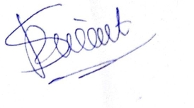

Mr. Ajay Sirsat
BOS Chairman
Department of Artificial Intelligence and Machine Learning,
SJCEM

