Department of Computer Science and Engineering (Data Science)
Toppers List A.Y. 2025/26

Semester 3 (S.E. DS)
Student Name | Score
Chadhana Ramesh Singh | 10.00
Randhawa Parmeet kaur | 10.00
Jain Vidhi Naresh Sangeeta | 10.00

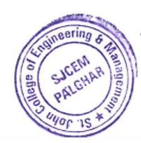
Semester 5 (T.E. DS)
Student Name | Score
Shukla Neha Rajesh | 10.00
Kakade Prem Bhaga | 10.00
Mogre Atharva | 10.00

